Lecture 6.
Contractile cells and tissues: classification.
Neuro-muscular tissue.
Smooth muscle tissue: histogenesis, innervation, vascularization.
Striated muscle tissue: genesis, morpho-functional features, innervation and vascularization.
Cardiac muscle tissue.
Growth and regeneration of muscle tissue.

Although many cells of multicellular organisms have limited contractile abilities, it is the capability of muscle cells, which are specialized for contraction, that permits animals to move. Organisms harness the contraction of muscle cells and the arrangement of the extracellular components of muscle to permit locomotion, constriction, pumping, and other propulsive movements. Cells of muscle are elongated and are called either striated muscle cells or smooth muscle cells, depending on the respective presence or absence of a regularly repeated arrangement of myofibrillar contractile proteins, the myofilaments. Striated muscle cells display characteristic alternations of light and dark cross-bands, which are absent in smooth muscle . There are two types of striated muscle: skeletal, accounting for most of the voluntary muscle mass of the body, and involuntary cardiac, limited almost exclusively to the heart. Smooth muscle cells are located in the walls of blood vessels and the viscera as well as in the dermis of the skin. Unique terms are often used to describe the components of muscle cells. Thus, muscle cell membrane is referred to as sarcolemma; the cytoplasm, as sarcoplasm; the smooth endoplasmic reticulum, as sarcoplasmic reticulum; and occasionally, the mitochondria, as sarcosomes. Because they are much longer than they are wide, muscle cells frequently are called muscle fibers; unlike collagen fibers, however, they are living entities. All three muscle types are derived from mesoderm. Cardiac muscle originates in splanchnopleuric mesoderm, most smooth muscle is derived from splanchnic and somatic mesoderm, and most skeletal muscles originate from somatic mesoderm.
SKELETAL MUSCLE. Skeletal muscle (Fig. 6.1) is composed of long, cylindrical, multinucleated cells that undergo voluntary contraction to facilitate movement of the body or its parts. During embryonic development, several hundred myoblasts, precursors of skeletal muscle fibers, line up end to end, fusing with one another to form long multinucleated cells known as myotubes. These newly formed myotubes manufacture cytoplasmic constituents as well as contractile elements, called myofibrils. Myofibrils are composed of specific arrays of myofilaments, the proteins responsible for the contractile capability of the cell. Muscle fibers are arranged parallel to one another, with their intervening intercellular spaces housing parallel arrays of continuous capillaries. Each skeletal muscle fiber is long, cylindrical, multinucleated, and striated. The diameters of the fibers vary, ranging from 10 to 100μm, although hypertrophied fibers may exceed. The relative strength of a muscle fiber directly depends on its diameter, whereas the strength of the entire muscle is a function of the number and thickness of its component fibers. Skeletal muscle is pink to red because of its rich vascular supply as well as the presence of myoglobin pigments, oxygen-transporting proteins that resemble, but are smaller than, hemoglobin.

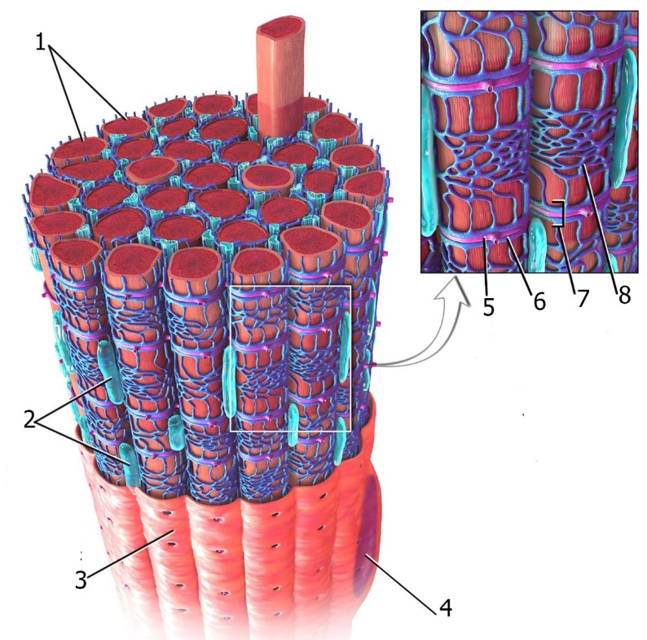

Fig. 6.1

Depending on the fiber diameter, quantity of myoglobin, number of mitochondria, extensiveness of the sarcoplasmic reticulum, concentration of various enzymes, and rate of contraction, the muscle fiber may be classified as red, white, or intermediate. Usually, a gross anatomical muscle (e.g., biceps) contains all three types of muscle fibers (red, white, and intermediate) in relatively constant proportions that are characteristic of that particular muscle. In chickens, for instance, thigh muscle fibers are predominantly red, and breast muscle fibers are predominantly white. The innervation of the muscle fiber appears to be the factor that determines fiber type. If the innervation is experimentally switched, the fiber accommodates itself to the new nerve supply.
Investments The investments of skeletal muscle are the epimysium, perimysium, and endomysium. The entire muscle is surrounded by epimysium, a dense irregular collagenous connective tissue. Perimysium, a less dense collagenous connective tissue derived from epimysium, surrounds bundles (fascicles) of muscle fibers. Endomysium, composed of reticular fibers and an external lamina (basal lamina), surrounds each muscle cell. Because these connective tissue elements are interconnected, contractile forces exerted by individual muscle cells are transferred to them. Tendons and aponeuroses, which connect muscle to bone and to other tissues, are continuous with the connective tissue encasements of muscle and, therefore, act in harnessing the contractile forces for motion. Light microscopy of skeletal muscle fibers displays long, cylindrical, multinucleated cells whose nuclei are peripherally located. Skeletal muscle fibers are multinucleated cells, with their numerous nuclei peripherally located just beneath the cell membrane. Each cell is surrounded by endomysium, whose fine reticular fibers intermingle with those of neighboring muscle cells. Small satellite cells, which have a single nucleus and act as regenerative cells, are located in shallow depressions on the muscle cell's surface, sharing the muscle fiber's external lamina. The chromatin network of the satellite cell nucleus is denser and coarser than that of the muscle fiber. Much of the skeletal muscle cell is composed of longitudinal arrays of cylindrical myofibrils, each 1 to 2 μm in diameter . They extend the entire length of the cell and are aligned precisely with their neighbors. This strictly ordered parallel arrangement of the myofibrils is responsible for the cross-striations of light and dark banding that are characteristic of skeletal muscle viewed in longitudinal section. The dark bands are known as A bands (anisotropic with polarized light) and the light bands as I bands (isotropic with polarized light). The center of each A band is occupied by a pale area, the H band, which is bisected by a thin M line. Each I band is bisected by a thin dark line, the Z disk (Z line). The region of the myofibril between two successive Z disks, known as a sarcomere, is 2.5 μm in length and is considered the contractile unit of skeletal muscle fibers (Fig. 6.2).

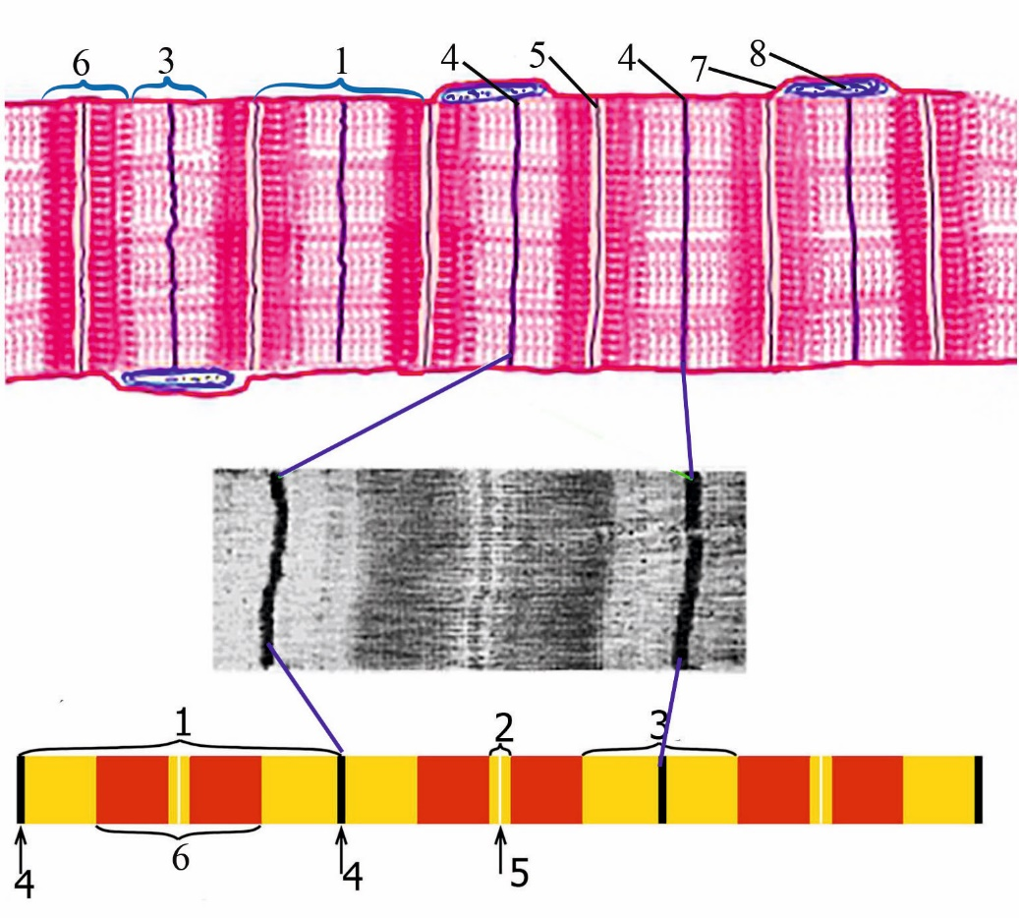

Fig. 6.2

During muscle contraction, the various transverse bands behave characteristically. The I band becomes narrower, the H band is extinguished, and the Z disks move closer together (approaching the interface between the A and I bands), but the width of the A bands remains unaltered.
Fine Structure of Skeletal Muscle Fibers. Electron microscopy has helped reveal the functional and morphological significance of skeletal muscle cross-striations and other structural components. T Tubules and Sarcoplasmic Reticulum T tubules and sarcoplasmic reticulum are essential components involved in skeletal muscle contraction. The fine structure of the sarcolemma is similar to that of other cell membranes. A distinguishing feature of this membrane, however, is that it is continued within the skeletal muscle fiber as numerous T tubules (transverse tubules), long, tubular invaginations that intertwine among the myofibrils. In mammalian skeletal muscle, T tubules pass transversely across the fiber and lie specifically in the plane of the junction of the A and I bands. These tubules branch and anastomose but usually remain in a single plane; hence, each sarcomere possesses two sets of T tubules, one at each interface of the A and I bands. Thus, T tubules extend deep into the interior of the fiber and facilitate the conduction of waves of depolarization along the sarcolemma. Associated with this system of T tubules is the sarcoplasmic reticulum, which is maintained in close register with the A and I bands as well as with the T tubules.

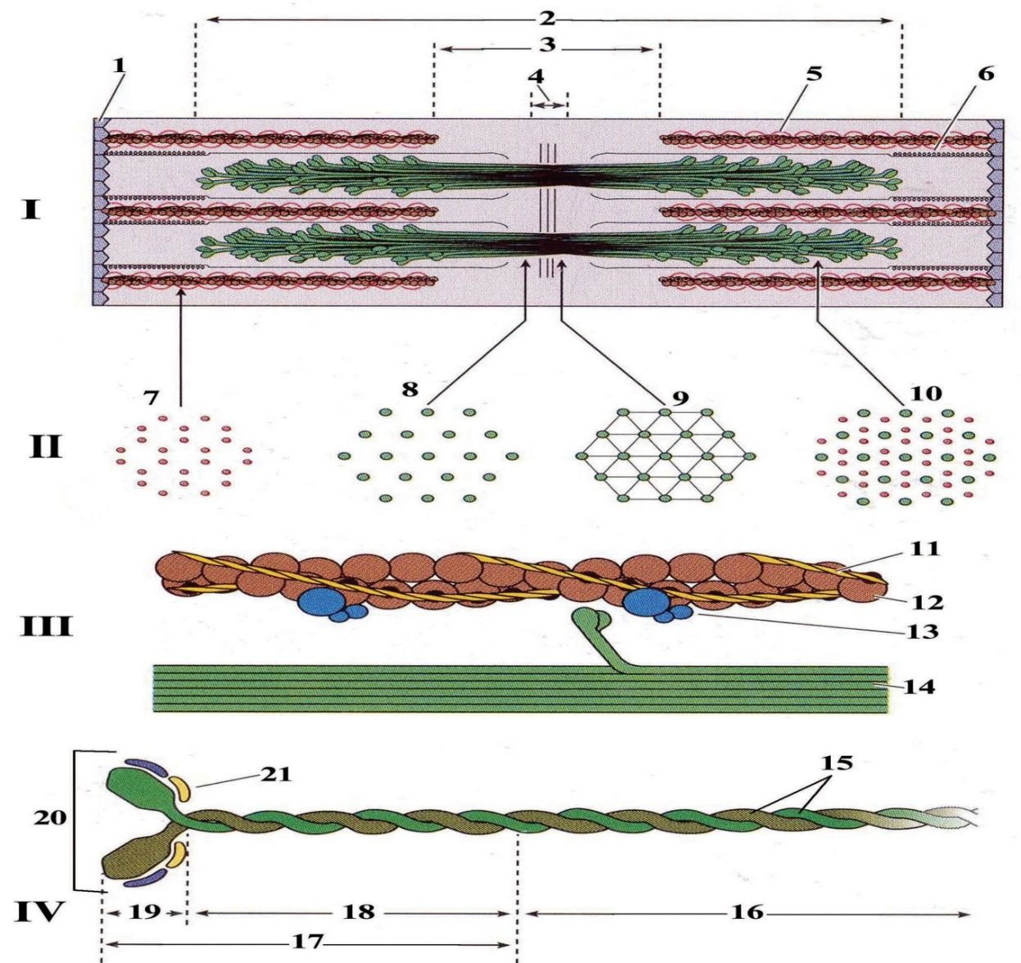

Fig. 6.3

The sarcoplasmic reticulum, which stores intracellular calcium, forms a meshwork around each myofibril and displays dilated terminal cisternae at each A-I junction. Thus, two of these cisternae are always in close apposition to a T tubule, forming a triad in which a T tubule is flanked by two terminal cisternae. This arrangement permits a wave of depolarization to spread, almost instantaneously, from the surface of the sarcolemma throughout the cell, reaching the terminal cisternae, which have voltage-gated calcium release channels (junctional feet) in their membrane. The sarcoplasmic reticulum regulates muscle contraction through controlled sequestering (leading to relaxation) and release (leading to contraction) of calcium ions (Ca²⁺) within the sarcoplasm. The trigger for the calcium ion release is the wave of depolarization transmitted by T tubules, which causes opening of the calcium release channels of the terminal cisternae, resulting in release of calcium ions into the cytosol in the vicinity of the myofibrils. Myofibrils are held in register with one another by the intermediate filaments desmin and vimentin, which secure the periphery of the Z disks of neighboring myofibrils to each other. These bundles of myofibrils are attached to the cytoplasmic aspect of the sarcolemma by various proteins, including dystrophin, a protein that binds to actin. Deep to the sarcolemma and interspersed between and among myofibrils are numerous elongated mitochondria with many highly interdigitating cristae. The mitochondria may either parallel the longitudinal axis of the myofibril or wrap around the myofibril. Moreover, numerous mitochondria are located just deep to the sarcoplasm.
Structural Organization of Myofibrils Myofibrils are composed of interdigitating thick and thin myofilaments. Electron microscopy reveals the same banding as noted by light microscopy but also demonstrates the presence of parallel, interdigitating, rod-like thick myofilaments and thin myofilaments (Fig. 6.3). The thick filaments (15 nm in diameter and 1.5 μm long) are composed of myosin II, whereas the thin filaments (7 nm in diameter and 1.0 μm long) are composed primarily of actin. Thin filaments originate at the Z disk and project toward the center of the two adjacent sarcomeres, thus pointing in opposite directions. Hence, a single sarcomere has two groups of parallel arrays of thin filaments, each attached to one Z disk, with all of the filaments in each group pointing toward the middle of the sarcomere . Thick filaments also form parallel arrays, interdigitating with the thin filaments in a specific fashion. In a relaxed skeletal muscle fiber, the thick filaments do not extend the entire length of the sarcomere, and the thin filaments projecting from the two Z disks of the sarcomere do not meet in the midline. Therefore, there are regions of each sarcomere, on either side of each Z disk, where only thin filaments are present. These adjacent portions of two successive sarcomeres correspond to the I band seen by light microscopy; for instance, the region of each sarcomere that encompasses the entire length of the thick filaments is the A band, and the zone in the middle of the A band, which is devoid of thin filaments, is the H band. As noted earlier, the H band is bisected by the M line, which consists of myomesin, C protein, and other as yet poorly characterized proteins that interconnect thick filaments to maintain their specific lattice arrangement. During contraction (Fig. 6.4), individual thick and thin filaments do not shorten; instead, the two Z disks are brought closer together as the thin filaments slide past the thick filaments (Huxley's sliding filament theory).

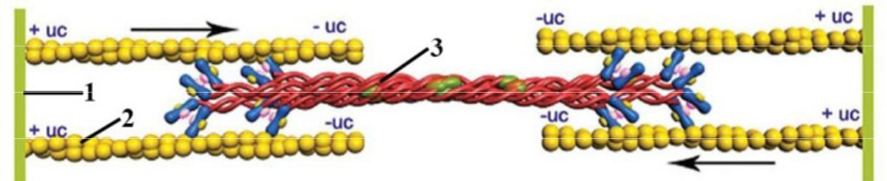

Fig. 6.4

Thus, when contraction occurs, the motion of the thin filaments toward the center of the sarcomere creates a greater overlap between the two groups of filaments, effectively reducing the widths of the I and H bands without influencing the width of the A band. The arrangement of the thick and thin filaments bears a specific and constant relationship. In mammalian skeletal muscle, each thick filament is surrounded equidistantly by six thin filaments. Cross sections through the region of overlapping thin and thick filaments display a hexagonal pattern, with thin filaments for the apices of each hexagon, the center of which is occupied by a thick filament. Thick filaments are separated from each other by a distance of 40 to 50nm, whereas the distance between thick and thin filaments is only 15 to 20nm. The structural organization of myofibrils is maintained largely by five proteins:
- Titin
- α-Actinin
- Cap Z
- Nebulin
- Tropomodulin
Thick filaments are positioned precisely within the sarcomere with the assistance of titin, a large, linear, elastic protein. Two titin molecules extend from each half of a thick filament to the adjacent Z disk; thus four titin molecules anchor a thick filament between the two Z disks of each sarcomere. Thin filaments are held in register by the rod-shaped protein α-actinin, a component of the Z disk that can bind thin filaments in parallel arrays. The plus end of the thin filament is held in place by a protein known as Cap Z that also prevents the addition or subtraction of G-actin molecules to or from the thin filament, thus assisting in the maintenance of its precise length. In addition, two molecules of nebulin, a long, nonelastic protein, are wrapped around the entire length of each thin filament, further anchoring it in the Z disk and ensuring the maintenance of the specific array of the thin filaments. Moreover, nebulin acts as a "ruler," ensuring the precise length of the thin filament. It is assisted in this function by the protein tropomodulin, a cap on the minus end of the thin filament that, similarly to Cap Z, prevents the addition or the deletion of G-actin molecules to or from the thin filament.
THICK FILAMENTS Thick filaments are composed of myosin II molecules aligned end to end. Every thick filament consists of 200 to 300 myosin II molecules. Each myosin II molecule (150 nm in length; 2 to 3 nm in diameter) is composed of two identical heavy chains and two pairs of light chains. The heavy chains resemble two golf clubs, whose rod-like polypeptide chains are wrapped around each other in an α-helix. The heavy chains can be cleaved by trypsin into:
- Light meromyosin, a rod-like tail composed of most of the two rod-like polypeptide chains wrapped around each other
- Heavy meromyosin, the two globular heads with the attendant short proximal portions of the two rod-like polypeptide chains wrapped around each other
Light meromyosin functions in the proper assembly of the molecules into the bipolar thick filament. Heavy meromyosin is cleaved by papain into two globular (S₁) moieties and a short, helical, rod-like segment (S₂) . The S₁ subfragment binds adenosine triphosphate (ATP) and functions in the formation of cross-bridges between the thick and thin myofilaments. Light chains (not to be confused with light meromyosin) are of two types, and one of each type is associated with each S₁ subfragment of the myosin II molecule. For each heavy chain, therefore, there are two light chains. A myosin II molecule is composed of two heavy chains and four light chains. Myosin II molecules are closely packed in a specific fashion in the thick filament. They are lined up in a parallel but staggered manner, spaced at regular intervals, lying arranged head to tail, so that the middle of each thick filament is composed solely of tail regions, whereas the two ends of the thick filament consist of both heads and tails. The spatial orientation of the myosin II molecules permits the heavy meromyosin portion to project from the thick filament at a 60-degree angle relative to neighboring heavy meromyosin, so that the head regions are always in register with the thin filaments. Each myosin II molecule appears to have two flexible regions, one at the junction of the heavy meromyosin and the light meromyosin and the other at the junction of the S₁ and S₂ subfragments. The flexible region between the heavy and light meromyosins permits each myosin II molecule to contact the thin filament, forming a cross-bridge between the two filament types. As discussed later, the flexible region between the S₁ and S₂ subfragments enables the myosin II molecule to drag the thin filament, incrementally, toward the middle of the sarcomere.
THIN FILAMENTS Thin filaments are composed of two chains of F-actin filaments wrapped around each other in association with tropomyosin and troponin. The major component of each thin filament is F-actin, a polymer of globular G-actin units. Although G-actin molecules are globular, they all polymerize in the same spatial orientation, imparting a distinct polarity to the filament. The plus end of each filament is bound to the Z disk by α-actinin; the minus end extends toward the center of the sarcomere. Each G-actin molecule also contains an active site, where the head region (S₁ subfragment) of myosin II binds. Two chains of F-actin are wound around each other in a tight helix (36-nm periodicity) like two strands of pearls. Running along the length of the F-actin double-stranded helix are two shallow grooves. Pencil-shaped tropomyosin molecules, about 40-nm long, polymerize to form head-to-tail filaments that occupy the shallow grooves of the double-stranded actin helix. Bound tropomyosin masks the active sites on the actin molecules by partially overlapping them. Approximately 25 to 30 nm from the beginning of each tropomyosin molecule is a single troponin molecule, composed of three globular polypeptides: TnT, TnC, and TnI. The TnT subunit binds the entire troponin molecule to tropomyosin; TnC has a great affinity for calcium; and TnI binds to actin, preventing the interaction between actin and myosin II. Binding of calcium by TnC induces a conformational shift in tropomyosin, exposing the previously blocked active sites on the actin filament so that myosin II molecules can flex, forming cross-bridges, and so that the S₁ moieties (myosin heads) can bind to the active site on the actin molecule.
Muscle Contraction and Relaxation. Muscle contraction obeys the "all-or-none law" and is followed by muscle relaxation. Contraction effectively reduces the resting length of the muscle fiber by an amount that is equal to the sum of all shortenings that occur in all sarcomeres of that particular muscle cell. The process of contraction, usually triggered by neural impulses, obeys the all-or-none law, in that a single muscle fiber either contracts as a result of stimulation or does not respond at all. The strength of contraction of a gross anatomical muscle, such as the biceps, is a function of the number of muscle fibers that undergo contraction. The stimulus is transferred at the neuromuscular junction. During muscle contraction, the thin filaments slide past the thick filaments, as proposed by Huxley's sliding filament theory. The following sequence of events leads to contraction in skeletal muscle:
- 1 An impulse, generated along the sarcolemma, is transmitted into the interior of the fiber via the T tubules, where it is conveyed to the terminal cisternae of the sarcoplasmic reticulum .
- 2 Calcium ions leave the terminal cisternae through voltage-gated calcium release channels, enter the cytosol, and bind to the TnC subunit of troponin, altering its conformation.
- 3 Conformational change in troponin shifts the position of tropomyosin deeper into the groove, unmasking the active site (myosin-binding site) on the actin molecule.
- 4 ATP present on the S₁ subfragment of myosin II is hydrolyzed, but both adenosine diphosphate (ADP) and inorganic phosphate (P_{i}) remain attached to the S₁ subfragment, and the complex binds to the active site on actin .
- 5 P_{i} is released, resulting not only in a greater bond strength between the actin and myosin II but also in a conformational alteration of the S₁ subfragment.
- 6 ADP is also released, and the thin filament is dragged toward the center of the sarcomere ("power stroke").
- 7 A new ATP molecule binds to the S₁ subfragment, causing the release of the bond between actin and myosin II.
The attachment and release cycles must be repeated numerous times for contraction to be completed. Each attachment and release cycle requires ATP for the conversion of chemical energy into motion. As long as the cytosolic calcium concentration is high enough, actin filaments remain in the active state and contraction cycles continue. Once the stimulating impulses cease, however, muscle relaxation occurs, involving a reversal of the steps that led to contraction. First, calcium pumps in the membrane of the sarcoplasmic reticulum actively drive Ca²⁺ back into the terminal cisternae, where the ions are bound by the protein calsequestrin. The reduced levels of Ca²⁺ in the cytosol cause TnC to lose its bound Ca²⁺; tropomyosin then reverts to the position in which it masks the active site of actin, preventing the interaction of actin and myosin II.
Energy Sources for Muscle Contraction Energy sources for muscle contraction are the phosphogen energy system, glycolysis, and the aerobic energy system. Because the process of muscle contraction consumes a great deal of energy, skeletal muscle cells maintain a high concentration of the energy-rich compounds ATP and creatine phosphate (or phosphocreatine). Because both ATP and creatine phosphate contain high-energy phosphate bonds, they constitute the phosphogen energy system, and can provide enough energy for about a total of 9 seconds of maximal muscle activity (3 seconds for ATP and 6 seconds for creatine phosphate). Additional energy can be derived from anaerobic metabolism of glycogen (glycolysis), which results in the formation and buildup of lactic acid. This is known as the glycogen-lactic acid system. This system provides about 90 to 100 seconds' worth of energy at almost maximal muscle activity. The third system, known as the aerobic energy system, uses the normal diet for the manufacture of ATP. The aerobic system does not support maximal muscle activity, but it can sustain normal muscle activity indefinitely if the dietary intake is maintained and the nutrients persist. ATP is manufactured via oxidative phosphorylation within the abundant mitochondria of muscle cells during periods of inactivity or low activity. Lipid droplets and glycogen, which abound in the sarcoplasm, also are readily converted into energy sources. The three metabolic systems of skeletal muscle are harnessed to supply the energy requirement of the muscle according to their activity modalities. During bursts of muscle contraction, the ADP that is generated is rephosphorylated by two means: (1) glycolysis, leading to accumulation of lactic acid, and (2) transfer of high-energy phosphate from creatine phosphate (phosphogen system) catalyzed by phosphocreatine kinase. During prolonged muscle activity, however, the aerobic system of energy production is employed.
Myotendinous Junctions The connective tissue elements of the muscle fiber are continuous with the tendon to which the muscle is attached. At the myotendinous junctions, the cells become tapered and highly fluted. Collagen fibers of the tendon penetrate deep into these infoldings and probably become continuous with the reticular fibers of the endomysium. Within the cell, the myofilaments are anchored to the internal aspect of the sarcolemma so that the force of contraction is transmitted to the collagen fibers of the tendon.
Innervation of Skeletal Muscle Skeletal muscle cells and the single motor neuron that innervates them constitute a motor unit. Each skeletal muscle receives at least two types of nerve fibers: motor and sensory. The motor nerve functions in eliciting contraction, whereas the sensory fibers pass to muscle spindles (see later). Additionally, autonomic fibers supply the vascular elements of skeletal muscle. The specificity of motor innervation is a function of the muscle innervated. If the muscle acts fastidiously, as do some muscles of the eye, a single motor neuron may be responsible for as few as 5 to 10 skeletal muscle fibers, whereas a muscle located in the abdominal wall may have as many as 1000 fibers under the control of a single motor neuron. Each motor neuron and the muscle fibers it controls form a motor unit. The muscle fibers of a motor unit contract in unison and follow the all-or-none law of muscle contraction.
Impulse Transmission at the Neuromuscular Junction. Impulse transmission from the motor neuron to the skeletal muscle fiber occurs at the neuromuscular junction. Motor fibers are myelinated axons of α-motor neurons, which pass in the connective tissue of the muscle. The axon arborizes, eventually losing its myelin sheath (but not its Schwann cells). The terminal of each arborized twig becomes dilated and overlies the motor end plates of individual muscle fibers. Each of these muscle-nerve junctions, known as a neuromuscular junction, is composed of an axon terminal, a synaptic cleft, and the muscle cell membrane. The muscle cell membrane (postsynaptic membrane) is modified, forming the primary synaptic cleft, a trough-like structure occupied by the axon terminal. Opening into the primary synaptic clefts are numerous secondary synaptic clefts (junctional folds), a further modification of the sarcolemma. Both the primary synaptic cleft and the junctional folds are lined by a basal lamina-like external lamina. The sarcoplasm in the vicinity of the secondary synaptic cleft is rich in glycogen, nuclei, ribosomes, and mitochondria. The axon terminal, covered by Schwann cells, houses mitochondria, smooth endoplasmic reticulum, and as many as 300,000 synaptic vesicles (each 40 to 50 nm in diameter) containing the neurotransmitter acetylcholine. The function of the neuromuscular junction is to transmit a stimulus from the nerve fiber to the muscle cell. Stimulus transmission across a synaptic cleft involves the following sequence of events:
- 1 A stimulus, traveling along the axon, depolarizes the membrane of the axon terminal, thus opening the voltage-gated calcium channels, located in the vicinity of linearly arranged structures known as dense bars.
- 2 The influx of calcium into the axon terminal results in the fusion of about 120 synaptic vesicles per nerve impulse with the axon terminal's membrane (presynaptic membrane) and subsequent release of acetylcholine (along with proteoglycans and ATP) into the primary synaptic cleft. Fusion occurs along specific regions of the presynaptic membrane, known as active sites, adjoining the dense bars.
- 3 The neurotransmitter acetylcholine (ligand) is liberated in large quantities, known as quanta (equal to 10,000 to 20,000 molecules), from the nerve terminal.
- 4 Acetylcholine then diffuses across the synaptic cleft and binds to postsynaptic acetylcholine receptors in the muscle cell membrane. These receptors, located in the vicinity of the presynaptic active sites, are ligand-gated ion channels, which open in response to the binding of acetylcholine. The resulting ion influx leads to depolarization of the sarcolemma and generation of an action potential.
- 5 The impulse generated spreads quickly throughout the muscle fiber via the system of T tubules, initiating muscle contraction.
To prevent a single stimulus from eliciting multiple responses, acetylcholinesterase, an enzyme located in the external lamina lining the primary and secondary synaptic clefts, degrades acetylcholine into acetate and choline, thus permitting the reestablishment of the resting potential. Degradation is so rapid that all of the released acetylcholine is cleaved within a few hundred milliseconds. Choline is transported back into the axon terminal by a sodium-choline symport protein powered by the sodium concentration gradient. Within the axon terminal, the acetylcholine is synthesized from activated acetate (produced in mitochondria) and the recycled choline, a reaction catalyzed by choline acetyl transferase. The newly formed acetylcholine is transported, through the use of an antiport system powered by a proton concentration gradient, into newly formed synaptic vesicles. In addition to the recycling of choline, the synaptic vesicle membrane is recycled to conserve the surface area of the presynaptic membrane. This membrane recycling is accomplished by the formation of clathrin-coated endocytotic vesicles, which become the newly formed synaptic vesicles.
Muscle Spindles and Golgi Tendon Organs. Muscle spindles and Golgi tendon organs are sensory receptors that monitor muscle contraction. The neural control of muscle function requires not only the capability of inducing or inhibiting muscle contraction but also the ability to monitor the status of the muscle and its tendon during muscle activity. This monitoring is performed by two types of sensory receptors:
- Muscle spindles, which provide feedback about the changes in muscle length as well as the rate of alteration in muscle length
- Golgi tendon organs, which monitor the tension as well as the rate at which the tension is being produced during movement
Information from these two sensory structures is generally processed at unconscious levels, within the spinal cord. The information also reaches the cerebellum and even the cerebral cortex, however, so a person may sense muscle position.
Muscle Spindles. Muscle spindles continuously monitor the length and the changes in length of the muscle. When muscle is stretched, it normally undergoes reflex contraction, or stretch reflex. This proprioceptive response is initiated by the muscle spindle, an encapsulated sensory receptor located among, and in parallel with, the muscle cells . Each muscle spindle is composed of 8 to 10 elongated, narrow, very small, modified muscle cells called intrafusal fibers, surrounded by the fluid-containing periaxial space, which in turn is enclosed by the capsule. The connective tissue elements of the capsule are continuous with the collagen fibers of the perimysium and endomysium. The skeletal muscle fibers surrounding the muscle spindle are unremarkable and are called extrafusal fibers. Intrafusal fibers are of two types: nuclear bag fibers and the more numerous, thinner nuclear chain fibers. Furthermore, there are two categories of nuclear bag fibers: static and dynamic. The nuclei of both types of fibers occupy the centers of the cells; their myofibrils are located on either side of the nuclear region, limiting contraction to the polar regions of these spindle-shaped cells. The central regions of the intrafusal fibers do not contract. The nuclei are aggregated in the nuclear bag fibers, whereas they are aligned in a single row in nuclear chain fibers. Within a specific muscle spindle, a single, myelinated, large, sensory nerve fiber (group Ia) wraps spirally around the nuclear regions of each of the three types of intrafusal fibers, forming the primary sensory endings (also known as dynamic and Ia sensory endings). Additionally, secondary sensory nerve endings (also known as static and II sensory nerve endings) are formed by group II nerve fibers, which wrap around every nuclear chain fiber as well as around the static nuclear bag fibers. The contractile regions of the intrafusal fibers receive two types of γ-motor neurons. Dynamic nuclear bag fibers are innervated by a dynamic γ-motor neuron, whereas all nuclear chain fibers as well as all of the static nuclear bag fibers are innervated by a static γ-motor neuron. The extrafusal fibers receive their normal nerve fibers, which are the large, rapidly conducting axons of α-efferent (motor) neurons. As a muscle is stretched, the intrafusal muscle fibers of its muscle spindle are also stretched, causing the primary (group Ia, dynamic) and secondary (group II, static) sensory nerve fibers to initiate an action potential; with increased stretching, these nerve fibers accelerate their rate of firing. Group Ia and group II fibers both respond to a stretching of the muscle at a constant rate. Only group Ia fibers, however, respond to a change in the rate at which stretching occurs, thus furnishing information concerning both the rapidity of movement and unanticipated stretching of the muscle. Firing of the γ-motor neurons causes the polar regions of the intrafusal fibers to contract. When this occurs, the noncontractile regions of the intrafusal fibers are stretched from both directions, resulting in activation of the primary and secondary sensory nerve endings. Modulation of γ-motor neuron activity sensitizes the muscle spindle so that it can react even to a small degree of muscle stretching, as follows:
- Firing of dynamic γ-motor neurons primes the dynamic nerve endings but not the static nerve endings (because their firing does not cause contraction of the static nuclear bag fibers).
- Firing of static γ-motor neurons increases the continuous, steady response of both group Ia and group II sensory fibers (because both fibers form sensory nerve endings on static nuclear bag and all nuclear chain intrafusal fibers). However, the dynamic sensory fiber response decreases (because static γ-motor neurons do not innervate dynamic nuclear bag fibers).
Thus, modulation of the γ-motor neuron activity gives the nervous system the ability to adjust the sensitivity of the muscle spindle.
Golgi Tendon Organs (Neurotendinous Spindles) Golgi tendon organs monitor the intensity of muscle contraction. Golgi tendon organs, also called neurotendinous spindles, are cylindrical structures about 1 mm in length and 0.1 mm in diameter. They are located at the juncture of a muscle with its tendon and are positioned in series with the muscle fibers. Golgi tendon organs are composed of wavy collagen fibers and the nonmyelinated continuation of a single type Ib axon that ramifies as free nerve endings in the interstices between the collagen fibers. When the muscle contracts, it places tensile forces on the collagen fibers, straightening them, with a consequent compression and firing of the entwined nerve endings. The rate of firing is directly related to the amount of tension placed on the tendon. When a muscle undergoes strenuous contraction, it may generate a great amount of force. To protect the muscle, bone, and tendon, Golgi tendon organs provide an inhibitory feedback to the γ-motor neuron of the muscle, resulting in relaxation of the contracting tendon's muscle. Thus, the Golgi tendon organs monitor the force of muscle contraction, whereas muscle spindles monitor the stretching of the muscle in which they are located. These two sensory organs act in concert to integrate spinal reflex systems.

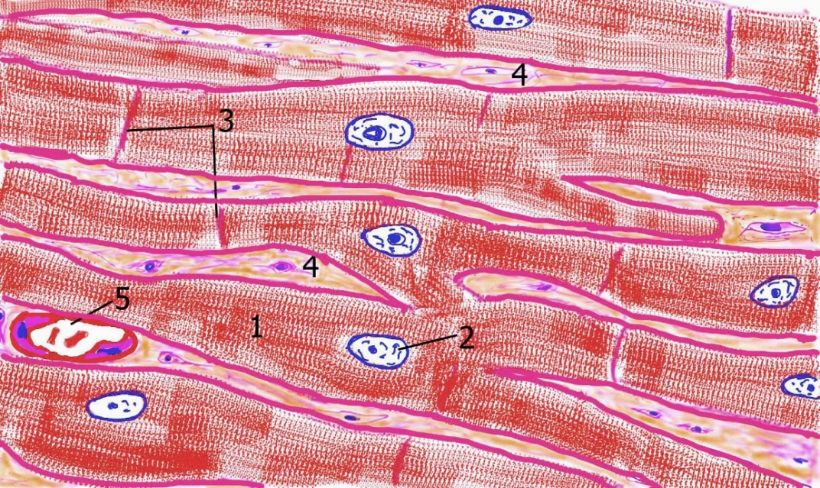
Fig. 6. 5

Cardiac muscle is nonvoluntary striated muscle limited to the heart and the proximal portions of the pulmonary veins. Cardiac muscle (heart muscle), another form of striated muscle, is found only in the heart and in pulmonary veins where they join the heart. Cardiac muscle is derived from a strictly defined mass of splanchnic mesenchyme, the myoepicardial mantle, whose cells give rise to the epicardium and myocardium. The adult myocardium (Fig. 6.5) consists of an anastomosing network of branching cardiac muscle cells arranged in layers (laminae). Laminae are separated from one another by slender connective tissue sheets that convey blood vessels, nerves, and the conducting system of the heart. Capillaries, derived from these branches, invade the intercellular connective tissue, forming a rich, dense network of capillary beds surrounding every cardiac muscle cell. Cardiac muscle differs from skeletal and smooth muscles in that it possesses an inherent rhythmicity as well as the ability to contract spontaneously. A system of modified cardiac muscle cells has been adapted to ensure the coordination of its contractile actions. Almost half the volume of the cardiac muscle cell is occupied by mitochondria, attesting to its great energy consumption. Glycogen, to a certain extent, but mostly triglycerides (∼60% during basal rate) form the energy supply of the heart. Because the oxygen requirement of cardiac muscle cells is high, they contain an abundant supply of myoglobin. Although the resting lengths of individual cardiac muscle cells vary, on average they are 15 μm in diameter and 80 μm in length. Each cell possesses a single, large, oval, centrally placed nucleus, although two nuclei are occasionally present Muscle cells of the atria are somewhat smaller than those of the ventricles. These cells also house granules (especially in the right atrium) containing atrial natriuretic peptide, a substance that functions to lower blood pressure. This peptide acts by decreasing the capabilities of renal tubules to resorb (conserve) sodium and water.
Intercalated Disks Cardiac muscle cells form highly specialized end-to-end junctions, referred to as intercalated disks. The cell membranes involved in these junctions approximate each other, so that in most areas they are separated by a space of less than 15 to 20nm. Intercalated disks have transverse portions, where fasciae adherentes and desmosomes abound, as well as lateral portions rich in gap junctions. On the cytoplasmic aspect of the sarcolemma of intercalated disks, thin myofilaments attach to the fasciae adherens, which are thus analogous to Z disks. Gap junctions, which function in permitting rapid flow of information from one cell to the next, also form in regions where cells lying side by side come in close contact with each other. Organelles. The extracellular fluid is the primary calcium source for cardiac muscle contraction. The bandings of cardiac muscle fibers are identical with those of skeletal muscle, including alternating I and A bands. Each sarcomere possesses the same substructure as its skeletal muscle counterpart; therefore, the mode and mechanism of contraction are virtually identical in the two striated muscles. Several major differences should be noted, however; they are found in the sarcoplasmic reticulum, the arrangement of T tubules, the Ca²⁺ supply of cardiac muscle, the ion channels of the plasmalemma, and the duration of the action potential. The sarcoplasmic reticulum of cardiac muscle does not form terminal cisternae and is not nearly as extensive as in skeletal muscle; instead, small terminals of sarcoplasmic reticulum approximate the T tubules. These structures do not normally form a triad, as in skeletal muscle; rather, the association is usually limited to two partners, resulting in a dyad. Unlike in skeletal muscle, where the triads are located at the A-I interfaces, the dyads in cardiac muscle cells are located in the vicinity of the Z line. The T tubules of cardiac muscle cells are almost two and one-half times the diameter of those in skeletal muscle and are lined by an external lamina. Because the sarcoplasmic reticulum is relatively sparse, it cannot store enough calcium to accomplish a forceful contraction; therefore, additional sources of calcium are available. Because the T tubules open into the extracellular space and have a relatively large bore, extracellular calcium flows through the T tubules and enters the cardiac muscle cells at the time of depolarization. Moreover, the negatively charged external lamina coating of the T tubule stores calcium for instantaneous release. Skeletal muscle cell action potential is achieved by an abundance of fast sodium channels, which open and close within a few ten-thousandths of a second, leading to the generation of very rapid action potentials. In addition to fast sodium channels, cardiac muscle cell membranes possess calcium-sodium channels (slow sodium channels). Although these channels are slow to open initially, they remain open for a considerable time (several tenths of a second). During this time, a tremendous number of sodium and calcium ions enter the cardiac muscle cell cytoplasm, thus increasing the calcium ion concentration supplied by the T tubule and the sarcoplasmic reticulum. An additional difference between the movement of ions in skeletal and cardiac muscle cells is that potassium ions can leave the skeletal muscle cells extremely quickly, thus reestablishing the resting membrane potential; in cardiac muscle cells, the egress of potassium ions is retarded, thus contributing to the protracted action potential.

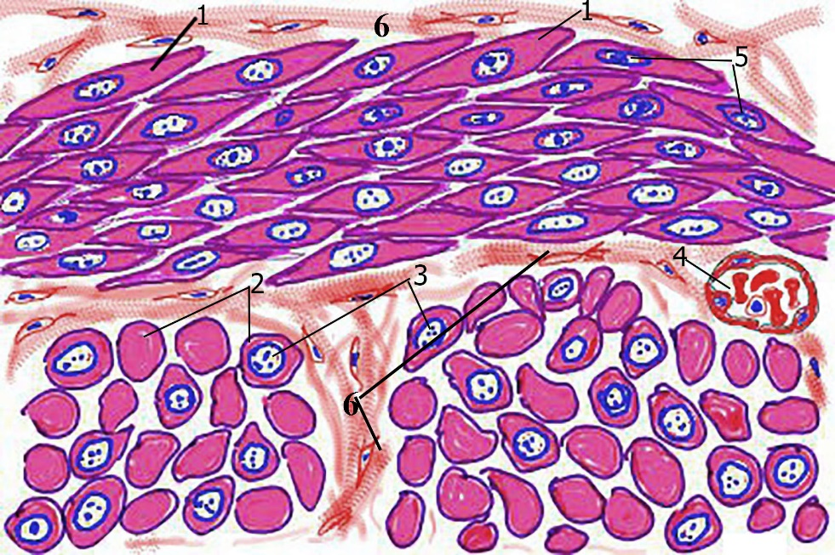

Fig. 6.6

The cells of the third type of muscle exhibit no striations; therefore, they are referred to as smooth muscle. Additionally, smooth muscle cells do not possess a system of T tubules . Smooth muscle (Fig. 6.6) is found in the walls of hollow viscera (e.g., the gastrointestinal tract, some of the reproductive tract, and the urinary tract), walls of blood vessels, larger ducts of compound glands, respiratory passages, and small bundles within the dermis of skin. Smooth muscle is not under voluntary control; it is regulated by the autonomic nervous system, hormones (such as bradykinins), and local physiological conditions. Hence, smooth muscle is also referred to as involuntary muscle. There are two types of smooth muscle:
- Cells of multiunit smooth muscle can contract independently of one another, because each muscle cell has its own nerve supply.
- Cell membranes of unitary (single-unit, vascular) smooth muscle form gap junctions with those of contiguous smooth muscle cells, and nerve fibers form synapses with only a few of the muscle fibers. Thus, cells of unitary smooth muscle cannot contract independently of one another.
In addition to its contractile functions, some smooth muscle is capable of exogenous protein synthesis. Among the substances manufactured by smooth muscle cells for extracellular utilization are collagen, elastin, glycosaminoglycans, proteoglycans, and growth factors. Smooth muscle fibers are fusiform, elongated cells whose average length is about 0.2 mm with a diameter of 5 to 6μm. The cells taper at either end, and the central portion contains an oval nucleus (Fig. 6.7) housing two or more nucleoli. During muscle shortening, the nucleus assumes a characteristic "corkscrew appearance," as a result of the method of smooth muscle contraction (Fig. 6.8). Each smooth muscle cell is surrounded by an external lamina, which invariably separates the sarcolemma of contiguous muscle cells. Embedded in the external lamina are numerous reticular fibers, which appear to envelop individual smooth muscle cells and function in harnessing the force of contraction.

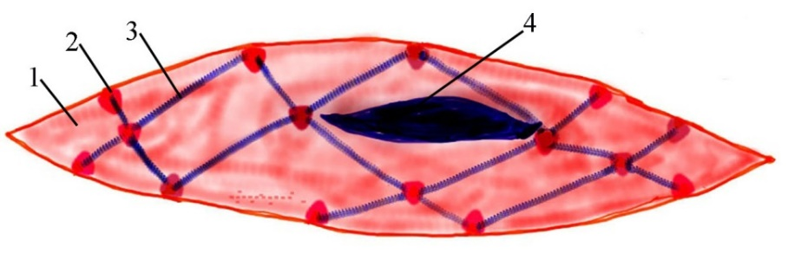

Fig. 6.7

With hematoxylin and eosin (HE) staining, the cytoplasm of smooth muscle fibers appears unremarkable; however, iron hematoxylin stain demonstrates the presence of dense bodies adhering to the cytoplasmic aspect of the cell membrane. In addition to dense bodies, thin, longitudinal striations may be evident in the sarcoplasm of smooth muscle cells, representing clumped associations of myofilaments. Smooth muscle cells usually form sheets of various thicknesses, although they may also occur as individual cells. When they form sheets, the cells are arranged so that they form a continuous network in which their tapered portions fit almost precisely into existing spaces between the expanded regions of neighboring smooth muscle cells. In cross section, outlines of various diameters may be noted, some containing nuclei, some not. Cross sections without nuclei represent the tapered ends of smooth muscle cells as they interdigitate with the other smooth muscle fibers. Sheets of smooth muscle cells are frequently arranged in two layers perpendicular to each other, as in the digestive and urinary systems. This arrangement permits waves of peristalsis.
Fine Structure of Smooth Muscle The perinuclear cytoplasm of smooth muscle cells, especially the regions adjacent to the two poles of the nucleus, contains numerous mitochondria, Golgi apparatus, rough endoplasmic reticulum (RER), smooth endoplasmic reticulum (SER), and inclusions such as glycogen . Additionally, an extensive array of interweaving thin filaments (7 nm) and thick filaments (15 nm) is present. The thin filaments are composed of actin (with its associated caldesmon, a protein that blocks the active site of F-actin, and tropomyosin, with the notable absence of troponin). The thick filaments are composed of the same myosin II that is present in skeletal muscle. Myofilaments of smooth muscle are not arranged in the paracrystalline fashion of striated muscle, and the organization of the thick filaments is not the same. Instead, the myosin II molecules are lined up so that the heavy meromyosin heads (S₁) project from the thick filaments throughout the length of the filament, with the two ends lacking heavy meromyosin. The middle of the filament, unlike that of striated muscle, also possesses heavy meromyosin, resulting in the availability of a larger surface area for the interaction of actin with myosin II and permitting contractions of long duration. The all-or-none law for striated muscle contraction does not apply to smooth muscle. The entire cell, or only a portion of the cell, may contract at a given instant even though the method of contraction probably follows the sliding filament theory of contraction. The contractile forces are harnessed intracellularly by an additional system of intermediate filaments, which consist of vimentin and desmin in unitary smooth muscle and desmin (only) in multiunit smooth muscle. These intermediate filaments as well as thin filaments insert into dense bodies, formed of α-actinin and other Z disk-associated proteins. Dense bodies may be located in the cytoplasm or associated with the cytoplasmic aspect of the smooth muscle sarcolemma. They are believed to resemble Z disks in function and in three dimensions may even be more extensive than formerly assumed, in that they form interconnected branching networks that extend throughout the cytoplasm. The force of contraction is relayed, through the association of myofilaments with dense bodies, to the intermediate filaments, which act to twist and shorten the cell along its longitudinal axis. Associated with the cell membrane domains are structures known as caveolae that act, among other functions, as T tubules of skeletal and cardiac muscle in regulating the cytosolic free calcium ion concentration.

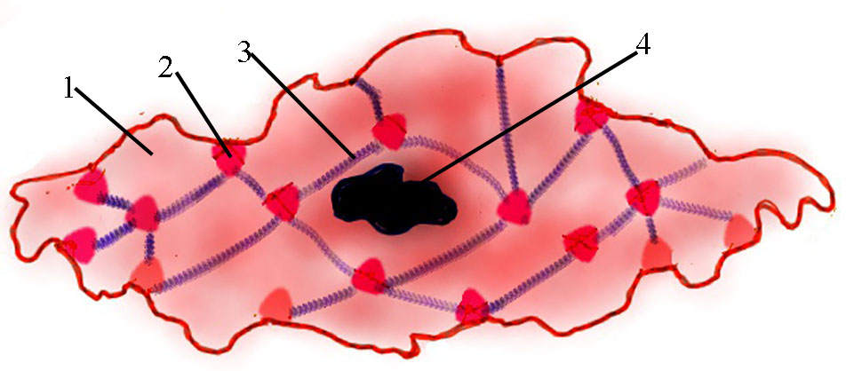

Fig. 6.8

Control of Smooth Muscle Contraction. Although the regulation of contraction in smooth muscle depends on Ca²⁺, the control mechanism differs from that encountered in striated muscle because smooth muscle thin filaments are devoid of troponin. Additionally, myosin II molecules assume a different configuration, in that their actin-binding site is masked by their light meromyosin moiety, and also their light chains are different from those of striated muscle. Contraction of smooth muscle fibers proceeds as follows:
- 1 Calcium ions, released from the sarcoplasmic reticulum as well as entering the cell at plasma membrane caveolae, bind to calmodulin (a regulatory protein ubiquitous in living organisms), thereby altering its conformation. The Ca²⁺-calmodulin complex binds to caldesmon, causing its release from the active site of F-actin, and then activates myosin light chain kinase.
- 2 Myosin light chain kinase phosphorylates one of the myosin light chains, known as the regulatory chain, permitting the unfolding of the light meromyosin moiety to form the typical, "golf club"-shaped myosin II molecule.
- 3 The phosphorylated light chain permits the interaction between actin and the S₁ subfragment of myosin II that results in contraction.
Because both phosphorylation and the attachment-detachment of the myosin cross-bridges occur slowly, the process of smooth muscle contraction takes longer than skeletal or cardiac muscle contraction. It is interesting that ATP hydrolysis also occurs much more slowly and the myosin heads remain attached to the thin filaments for a longer time in smooth muscle than in striated muscle. Thus, smooth muscle contraction not only is prolonged but also requires less energy. Decrease in the sarcoplasmic calcium level results in the dissociation of the calmodulin-calcium complex, causing inactivation of myosin light chain kinase. The subsequent dephosphorylation of myosin light chain, catalyzed by the enzyme myosin phosphatase, brings about masking of the myosin's actin binding site and the subsequent relaxation of the muscle.
Innervation of Smooth Muscle. Neuromuscular junctions in smooth muscle are not as specifically organized as those in skeletal muscle. The synapses may vary from 15 to 100 nm in width. The neural component of the synapse is the en passant type, which occurs as axonal swellings that contain synaptic vesicles, housing either norepinephrine for sympathetic innervation or acetylcholine for parasympathetic innervation. In certain cases, every smooth muscle cell receives individual innervation, as in the iris and the vas deferens. As indicated previously, smooth muscle innervated in this fashion is referred to as multiunit. Other smooth muscle cells, such as those of the gastrointestinal tract and uterus, do not possess individual innervation; rather, only a few muscle cells are equipped with neuromuscular junctions. As discussed previously, impulse transmission in these muscles, referred to as unitary (single-unit or visceral smooth muscles), occurs via nexus (gap junctions) formed between neighboring smooth muscle cells. Visceral smooth muscle may also be regulated by humoral or microenvironmental factors, such as oxytocin in the uterus or stretching of the muscle fibers in the intestines. Still other smooth muscles of the body are of an intermediate type, in which a certain percentage (30% to 60%) of the cells receive individual innervation.
Regeneration Of Muscle. Although skeletal muscle cells do not have the capability of mitotic activity, the tissue can regenerate because of the presence of satellite cells. These cells may undergo mitotic activity, resulting in hyperplasia, subsequent to muscle injury. Under certain other conditions, such as "muscle building," satellite cells may fuse with existing muscle cells, thus increasing muscle mass during skeletal muscle hypertrophy. Skeletal muscle cells regulate their number and their size by the secretion of a member of the transforming growth factor-β (TGF-β) superfamily of extracellular signaling molecules, myostatin. Certain mutant mice, whose skeletal muscle fibers cannot produce myostatin have enormous muscles that not only have many more cells but whose muscle cells are much larger than those of normal mice.
Cardiac muscle is incapable of regeneration. Following damage, such as a myocardial infarct, fibroblasts invade the damaged region, undergo cell division, and form fibrous connective tissue (scar tissue) to repair the damage. Smooth muscle cells retain their mitotic capability to form more smooth muscle cells. This ability is especially evident in the pregnant uterus, where the muscular wall becomes thicker both by hypertrophy of individual cells and by hyperplasia derived from mitotic activity of the smooth muscle cells. Small defects, subsequent to injury, may result in formation of new smooth muscle cells. These new cells may be derived via mitotic activity of existing smooth muscle cells, as in the gastrointestinal and urinary tracts, or from differentiation of relatively undifferentiated pericytes accompanying some blood vessels. Certain cells associated with glandular secretory units possess contractile capabilities. These myoepithelial cells are modified to assist in the delivery of the secretory products into the ducts of the gland. Myoepithelial cells are flattened and possess long processes that wrap around the glandular units . Myoepithelial cells contain both actin and myosin. Mechanisms and control of contraction in myoepithelial cells resemble, but are not identical to, those in smooth muscle. In lactating mammary glands, myoepithelial cells contract upon the release of oxytocin; in the lacrimal gland, they contract because of the action of acetylcholine. Myofibroblasts resemble fibroblasts but have abundant actin and myosin. They can contract and are especially prominent in wound contraction and tooth eruption.

